* Dropdown menu not working.

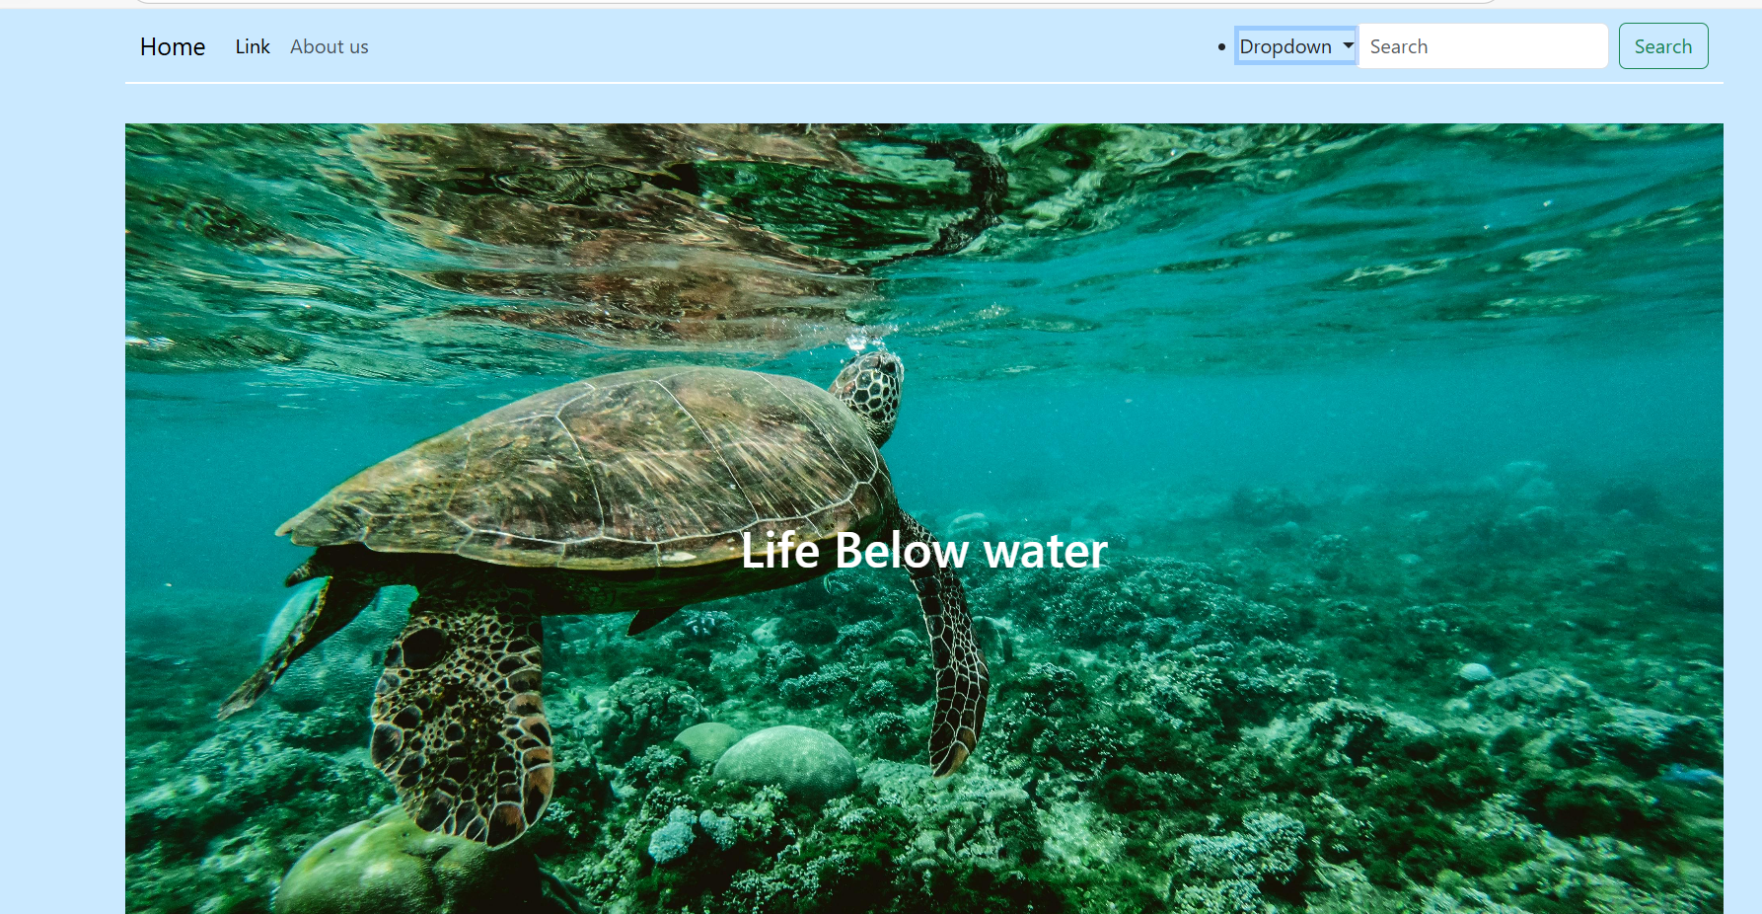

* Navbar sectioned and organised, still not working properly

* Sticky navbar working

* Css included

* Planning to ad js to this cards

* Js added to the cards transforming them into a mini game

* Dropdown menu on the navbar is finally working.

